**Data model maintenance**

Data model maintenance principles are

* All Data model changes are managed in GIT in FRMS-platform data repository so the changes can be reproduced and tracked.
* Changes to data model and background data shall be easy to deliver to end users
* Background data is always maintained in central database
* Repeatable, hi quality process

*Data model scripts and change process*

Datamodel scripts for all FRMS modules are maintained in frms-platform GIT repository. The data model change process as well as the GIT repository is described in [Data_Model resources and change process](Data_Model%20resources%20and%20change%20process.docx) document . Patches and data model scripts must follow naming conventions presented in [Code Repositories Overview](../../FRMS%20software%20development/Code_Repositories_Overview.docx) document

*Creation of local database*

Local database is created with Database admin utility which creates the data model (data-forest and symds schemes, tables, functions and triggers) and then reads the data to the background data tables from the Central database ( Tables considered as background data are the ones having a circle in “Transfer to local DB” column of [Data Model Capabilities](Data_model_capabilities.xlsx) document.

Local Database is always built by DA from data model scripts. Data model is only schema, not data!

When data model is changed

* Update data model scripts for local database
* Create patches for central database
* data model version is raised by 1.
* The local database is created by database-admin utility

*Updating background data in local database*

Any data upload must be handled between releases as patches to Central database.

* First Central Database gets data by patch
* Then Local Database gets data from Central Database by Database-Admin utility (Background data) or synchronization (user data).

The Central database is considered “master” when the background data in local database is changed. This means that background data shall always be done in the central database and then, depending on the type of the data, the changes are read to local database by Database Admin utility when the local database is created or during the synchronization.

* Data in Local Database is populated by 2 ways:
  + at LDB creation time by DA tool it transfers "static" and background data from CDB in corresponding environment.
  + Any other data (user's data) is managed by Synchronization

Data must not be inserted to LDB from any scripts. Inserting background data Local Database via database patches is not correct method in FRMS context.

Datamodel and background data maintenance is illustrated in the diagram 1.

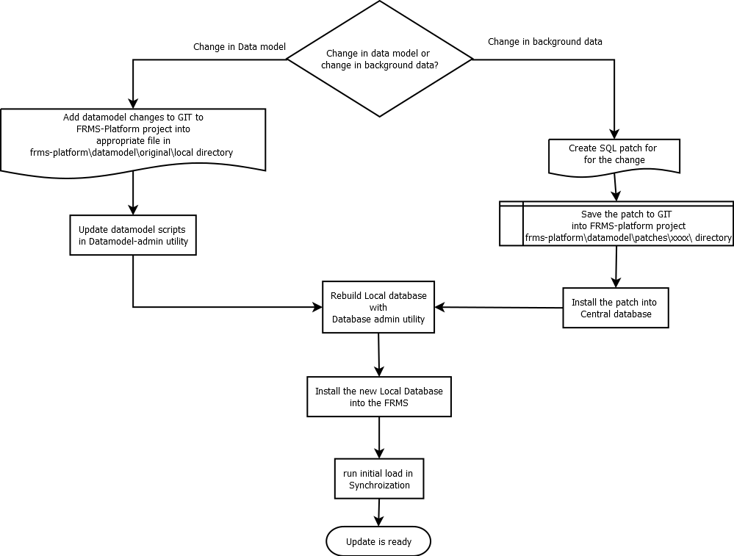

*Diagram 1: Datamodel and background data maintenance workflow*